Install Object Detection Report

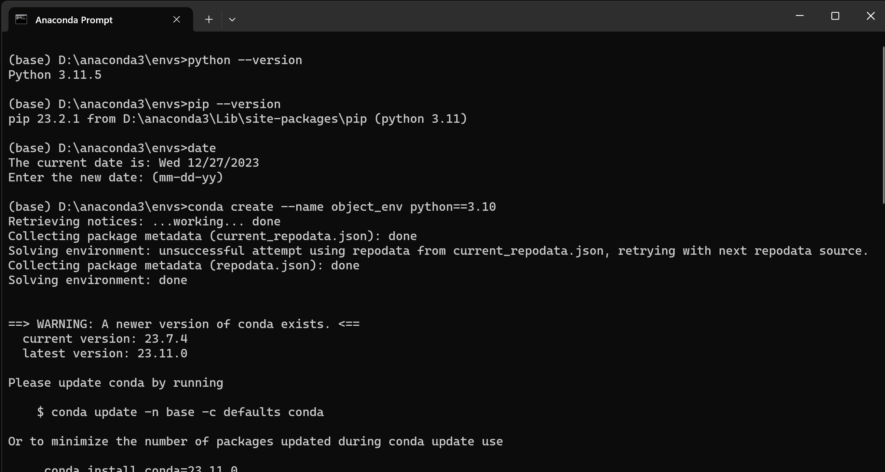

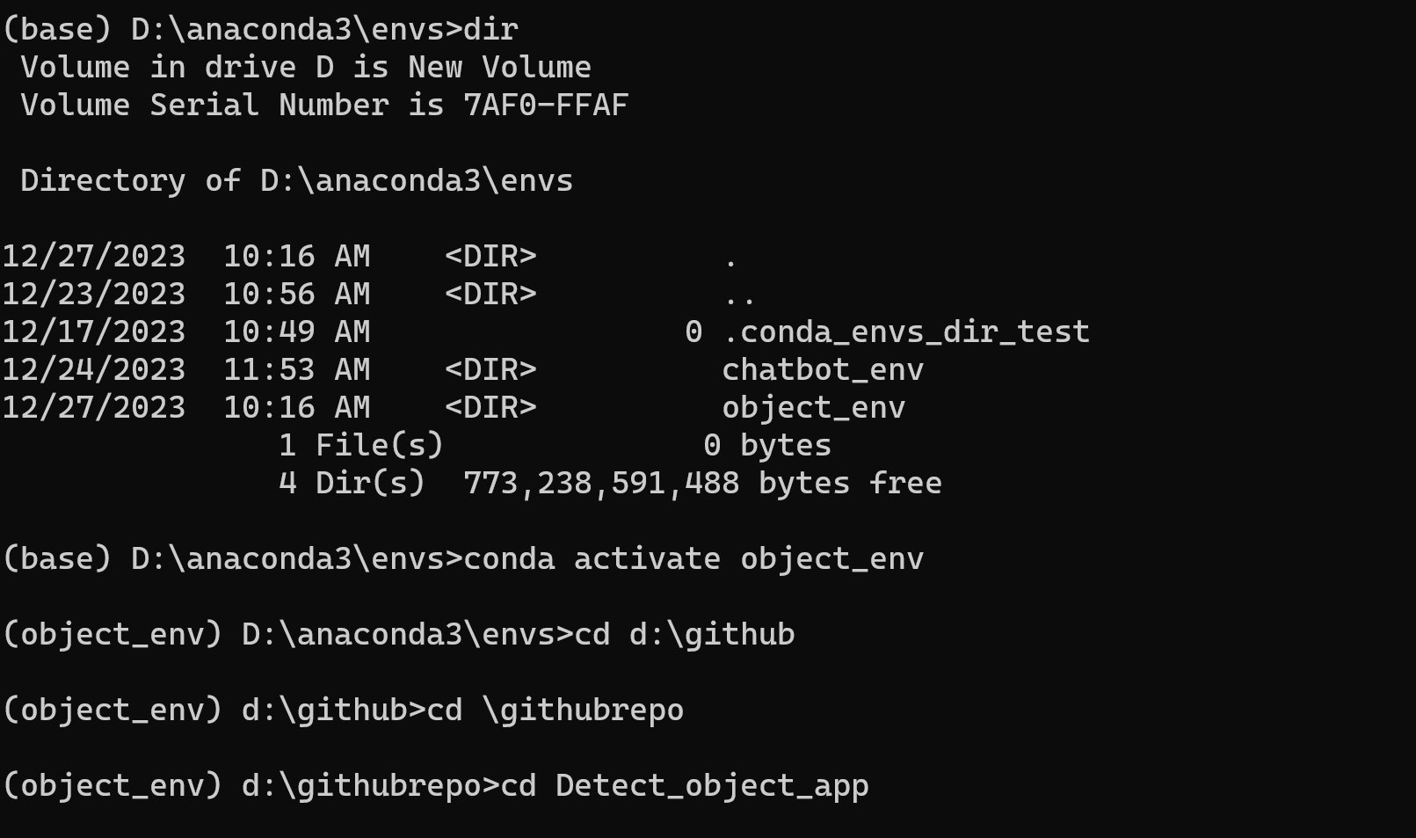

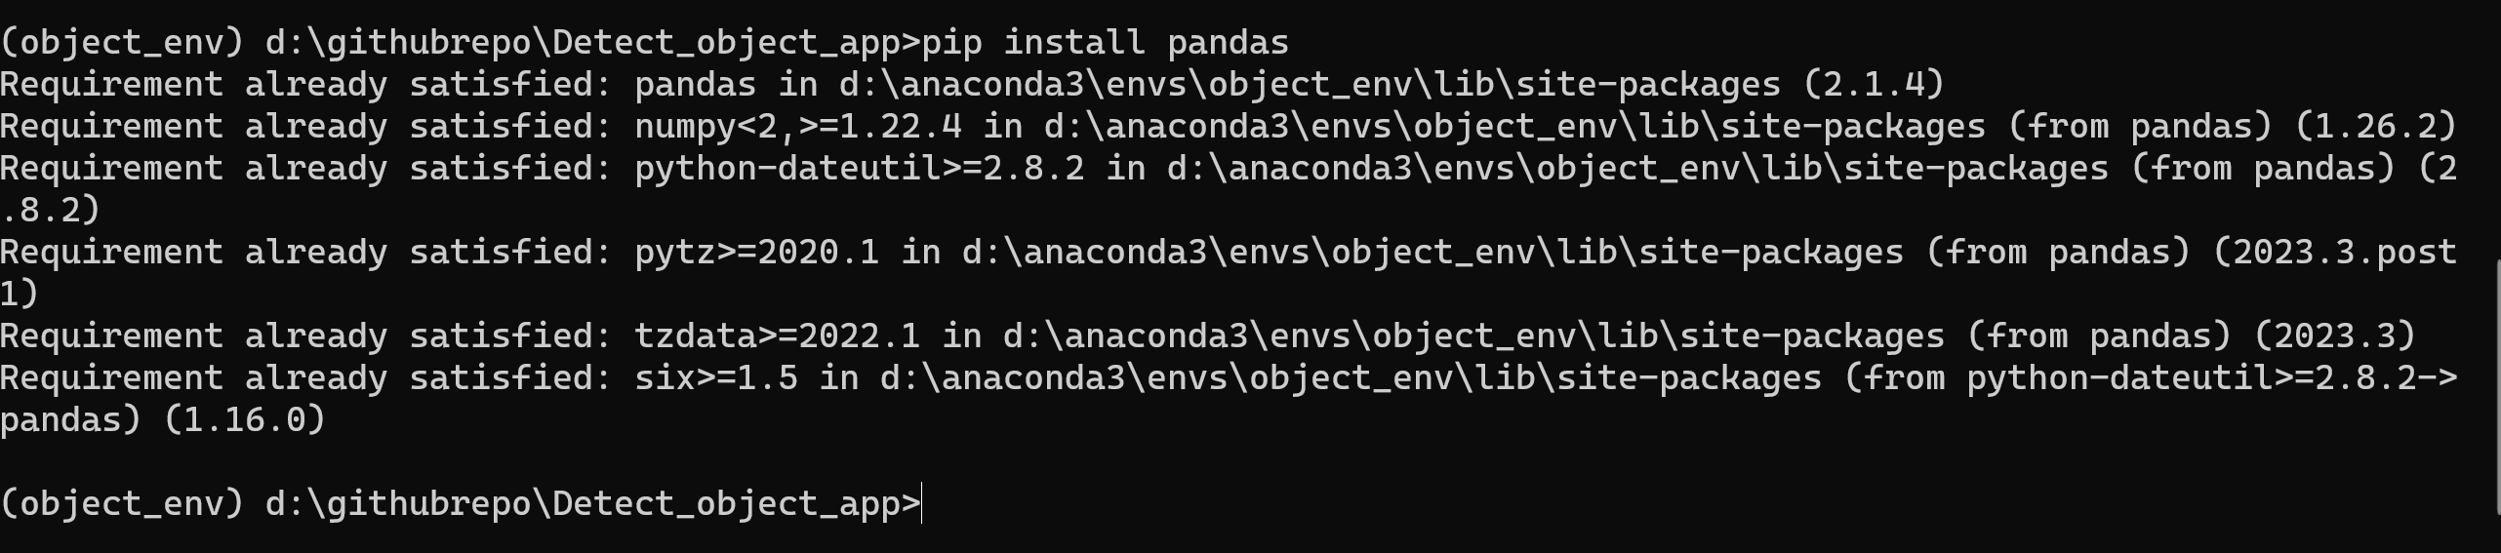

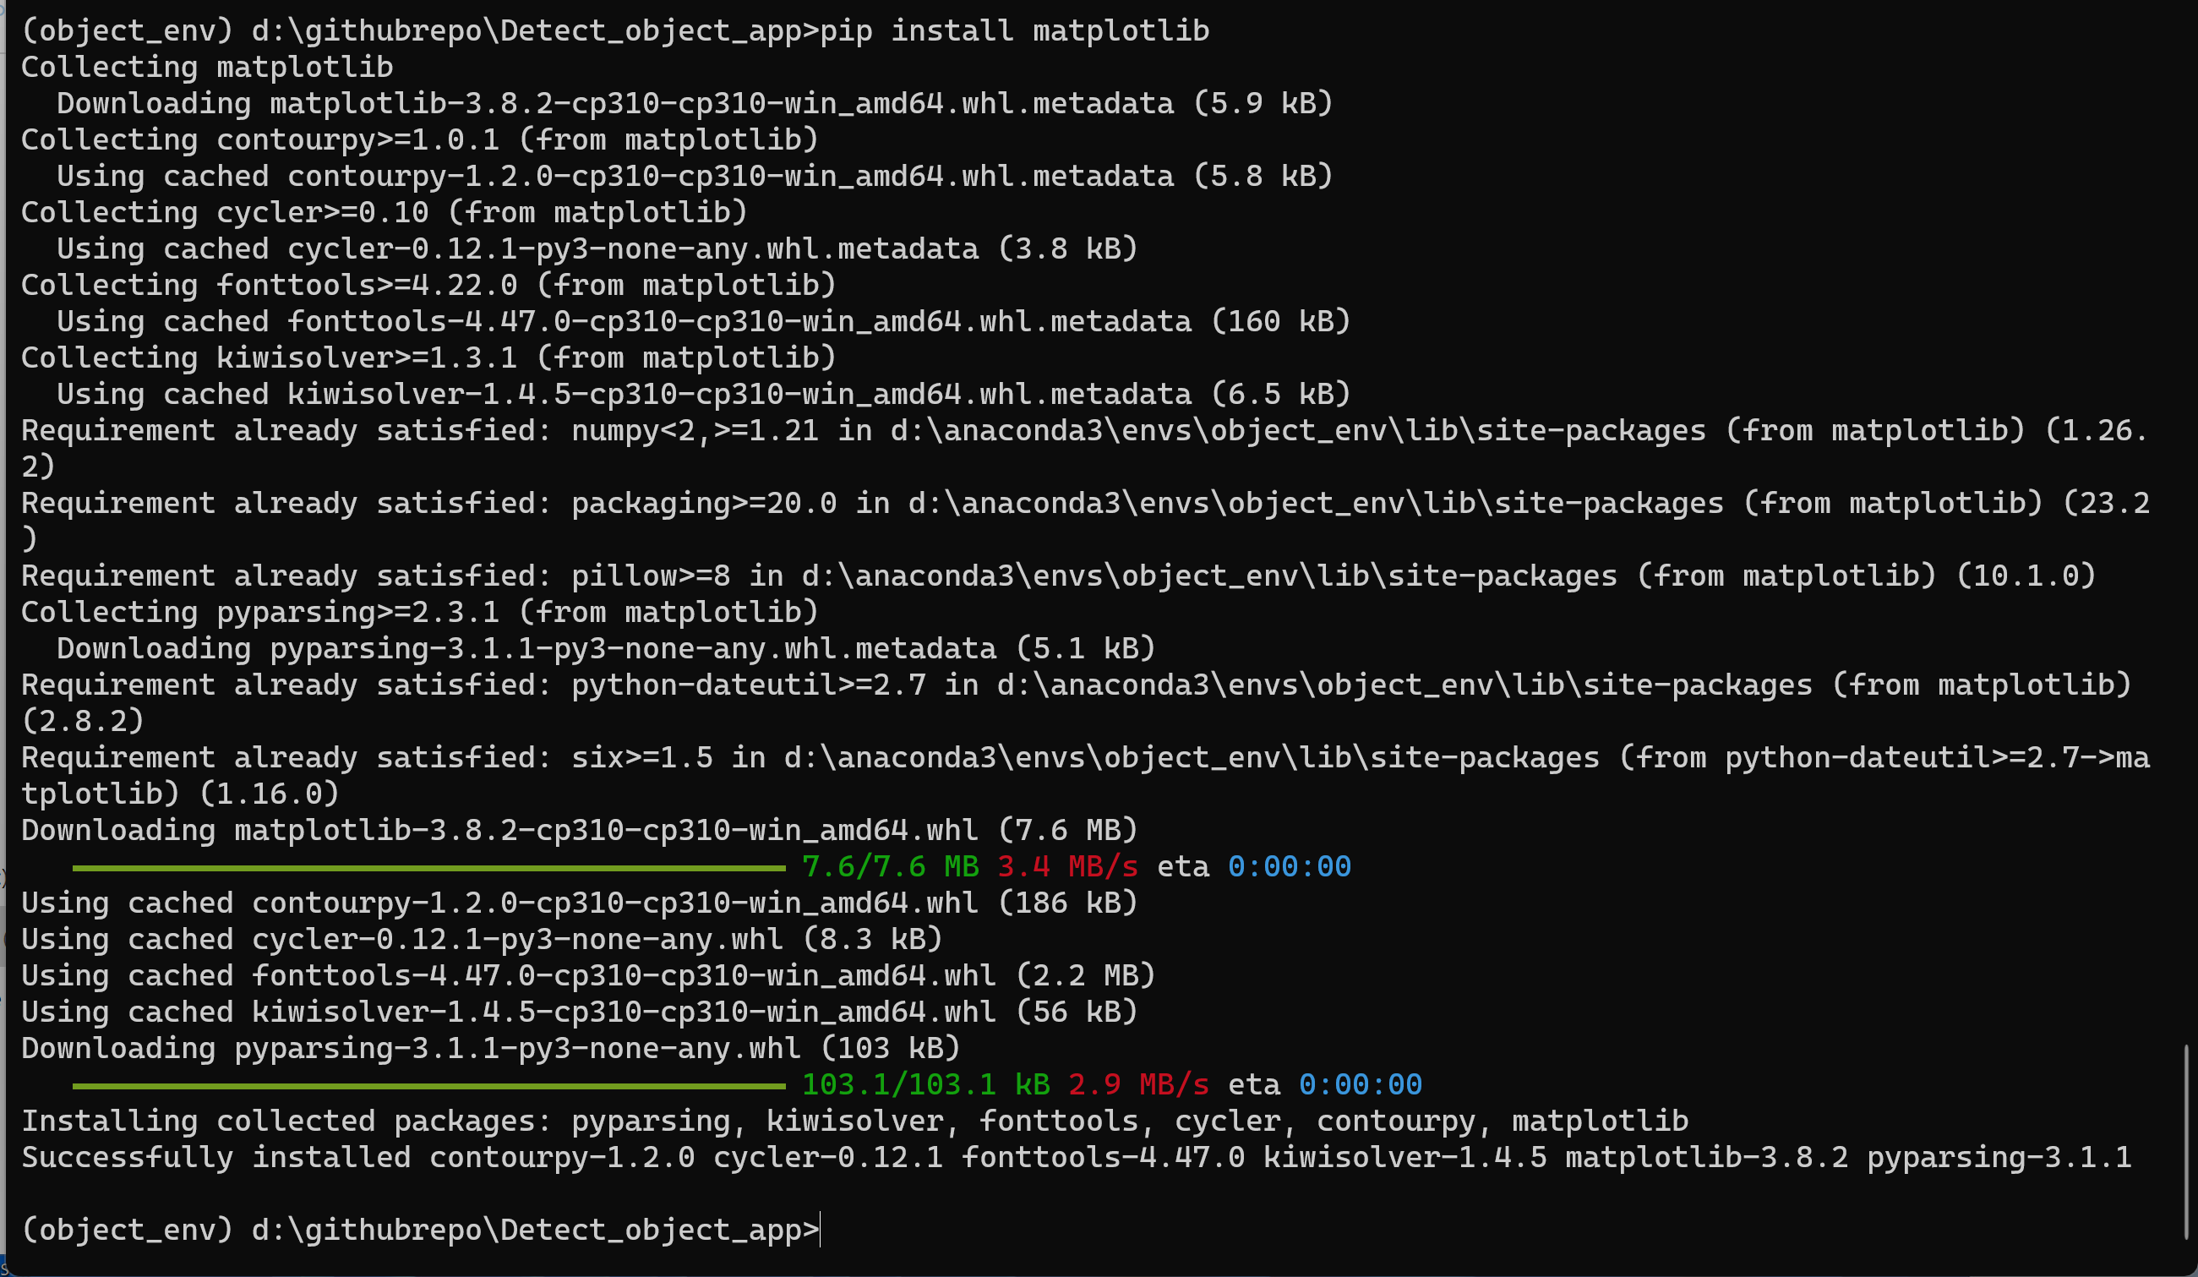

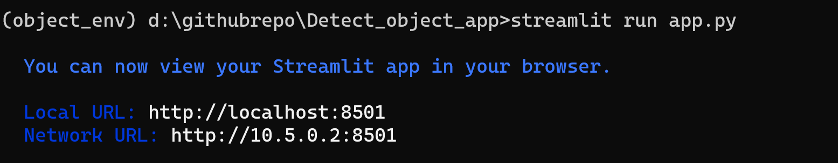

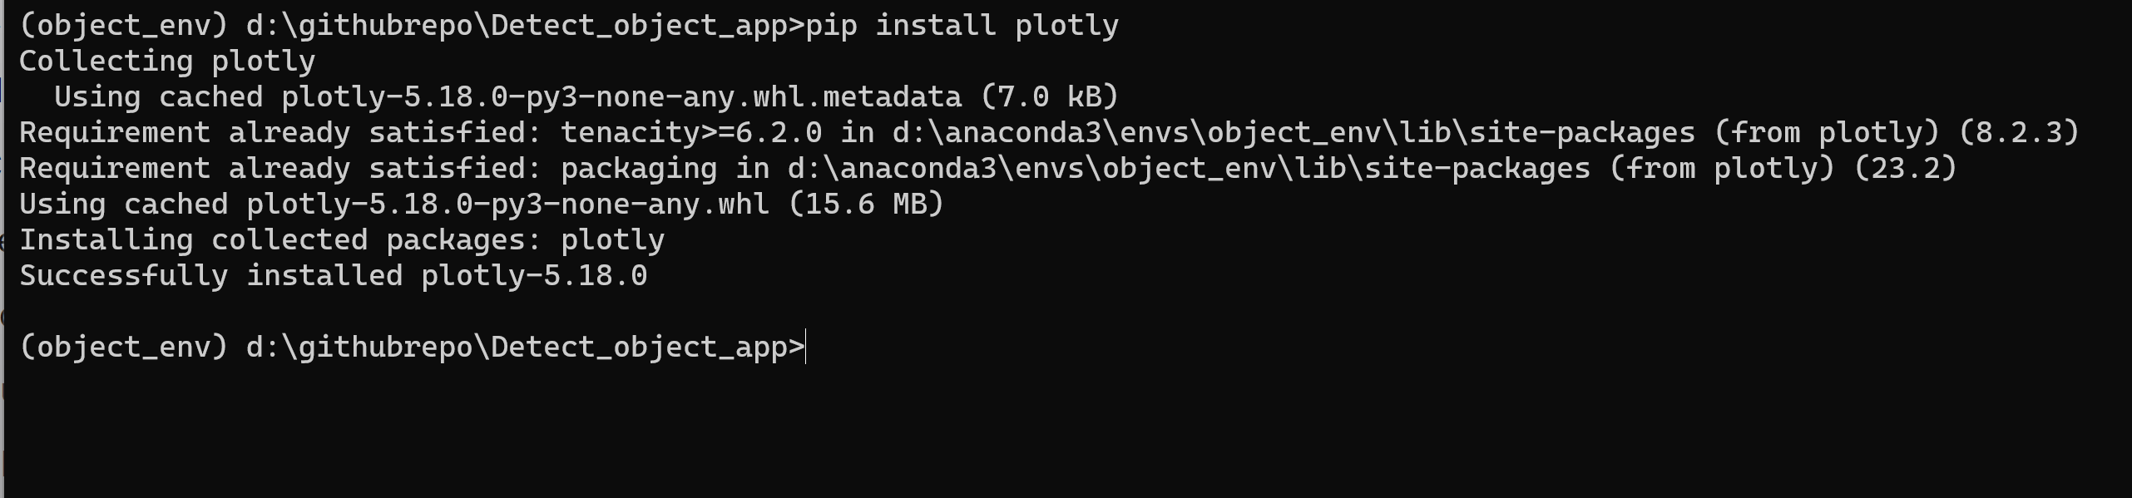

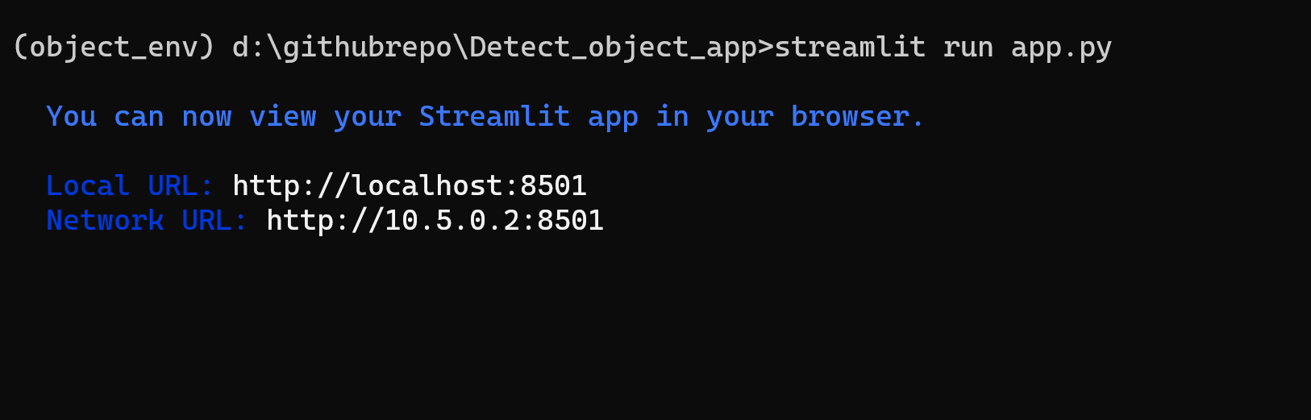

How to change the title:

On the line 82 you can change the title

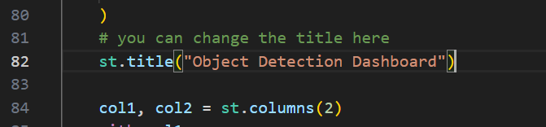

How to change the logo:

On the line 51 just change the name of the file where it is “YOLO.png” at the moment. Make sure to put the image file in the directory.

